NORTHWIND INTERACTIVE SALES DASHBOARD
Using Microsoft Power BI

Project Report
Submitted By Name: HANIJA R S
Tool Used: Microsoft Power BI Desktop

1. Introduction
For this task, I created an interactive sales dashboard using Microsoft Power BI with the Northwind dataset. The main purpose of creating this dashboard was to understand the sales performance, order details, customers, freight and product categories in a simple visual format.
I used different types of charts, KPI cards and slicers to present the information. The dashboard helps me quickly understand the overall sales performance and also allows me to view the data based on year, region and category.

2. Objectives
The main objectives of my Power BI dashboard were:
- To analyse the overall sales and order performance.
- To understand the number of orders received each month.
- To compare the orders handled by different employees.
- To analyse sales based on different product categories.
- To identify the total number of customers.
- To understand the freight amount and average freight.
- To make the report interactive using slicers.
- To present the business information in an easy-to-understand visual format.

3. Dataset Used
For this dashboard, I worked with the Northwind dataset. The data contains information related to orders, customers, employees, products and sales.
Some of the important information used in my dashboard includes:
- Orders – Used to analyse the total number of orders.
- Order Date – Used to show the monthly order trend.
- Employee Name – Used to compare the number of orders handled by employees.
- Category Name – Used to analyse sales according to product categories.
- Freight – Used to calculate the total and average freight.
- Customers – Used to identify the number of customers.
- Quantity Sold – Used to understand the total quantity of products sold.
- Sales – Used to calculate the overall sales amount.

4. Data Preparation in Power BI
First, I imported the Northwind data into Power BI Desktop. Before creating the dashboard, I checked the data and made sure that the required columns were available in the correct format. I worked with the order, sales, customer, employee, category and freight information to create the required visuals. I also prepared the necessary calculations for displaying the important values in the KPI cards. After preparing the data, I started creating different charts and interactive filters for the dashboard.

5. Measures / Calculations Used
I created calculations to display the main performance indicators in the dashboard.
The important calculations were:
- Total Orders – To find the overall number of orders.
- Total Sales – To calculate the total sales value.
- Total Freight – To find the total freight amount.
- Average Freight – To calculate the average freight per order.
- Number of Customers – To identify the total customers.
- Total Quantity Sold – To calculate the total quantity of products sold.
These calculations helped me display the important business information using KPI cards.

6. Dashboard Components

Total Orders by Month
I created a line chart to show the number of orders received during each month. This helped me understand how the order volume changed throughout the year. From the chart, I could see that the number of orders varied from month to month, with some months having considerably more orders than others.
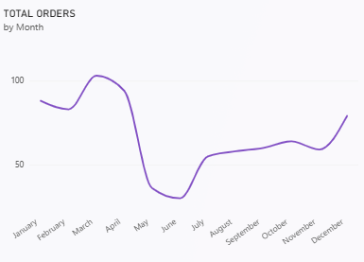

Total Orders by Employee
I used a bar chart to compare the number of orders handled by different employees. From this visual, I could easily identify which employees handled more orders and which employees had comparatively fewer orders. Margaret Peacock had the highest number of orders among the employees shown in the dashboard.
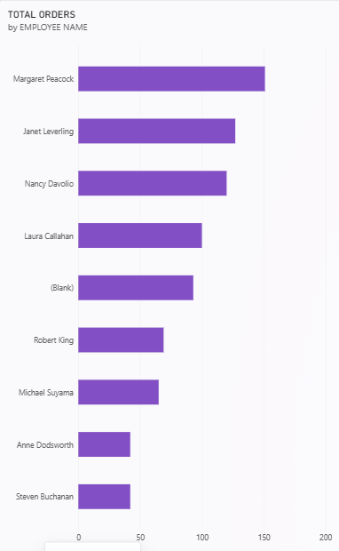

Total Sales by Category
I created a column chart to compare sales across different product categories. The chart shows that Beverages had the highest sales among the categories shown, followed by Dairy Products. Other categories such as Meat & Poultry, Confections, Seafood, Condiments, Produce and Grains & Cereals also contributed to the overall sales.
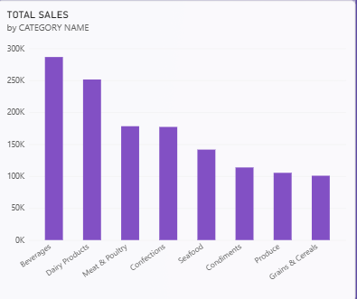

KPI Cards
I used KPI cards to display the main values of the business performance. The dashboard currently shows:
- Average Freight: 79.05
- Number of Customers: 91
- Total Freight: 63.96K
- Total Sales: 1.35M
- Total Orders: 809
- Total Quantity Sold: 51K
These cards make it easier to understand the overall performance without checking each chart separately.
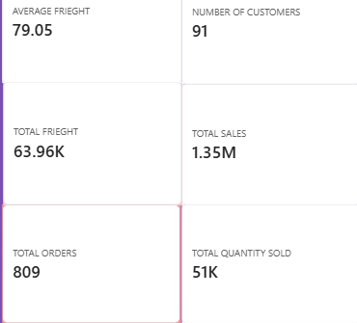

7. Slicers Used
To make my dashboard interactive, I added three slicers:
- Year
- Region
- Category
These slicers allow me to select a particular year, region or product category. When I change the selection, the dashboard visuals update according to the selected information. This makes it easier to analyse specific parts of the Northwind sales data instead of looking at the complete dataset every time.
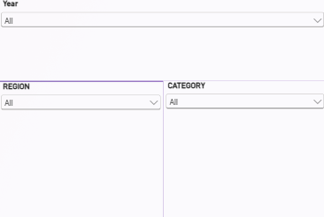

8. Key Findings
After completing my Power BI dashboard, I identified the following findings:
- The dashboard shows a total of 809 orders.
- The total sales amount is approximately 1.35 million.
- The total freight amount is around 63.96K.
- The average freight is 79.05.
- The dataset contains 91 customers.
- Around 51K quantities of products were sold.
- The number of orders changes from month to month.
- Margaret Peacock has the highest number of orders among the employees displayed.
- Beverages recorded the highest sales among the product categories shown.
- Dairy Products were the second-highest category in terms of sales.
- The slicers make it easier to analyse the dashboard based on year, region and category.

9. Conclusion
By completing this Northwind Sales Dashboard in Power BI, I got practical experience in converting business data into useful visual information. I learned how to use different charts, KPI cards and slicers to analyse sales and order-related data. The dashboard helped me understand the performance of different employees and product categories, along with important measures such as total sales, total orders, freight and quantity sold. The interactive filters also made the dashboard easier to explore. Overall, this task helped me improve my practical knowledge of Microsoft Power BI and understand how interactive dashboards can be used to analyse business data and support better decision-making.

10. References
- Microsoft Power BI Desktop
- Northwind Dataset
- Microsoft Power BI Documentation

